TEACHERS: PLEASE POST

STUDENTS: SHARE WITH PARENTS

Gregory-Portland High School
SCHOLARSHIP NEWSLETTER
School Code: 442990

Please Feel Free to Visit the Counseling Department for any questions about college & scholarships
Lead Counselor: Mrs. West A – Go College & Career Counselor: Mrs. Teel
Counselor: Mrs. Corpus Gr – O College Center Mentors:
Counselor: Mrs. Harley (P-Z) Gabby Bidwell (M-W-F)
PEIMS Clerk: Mrs. Austell Marco Campos (Monday)
Registrar: Mrs. Powers

Need help with applying to college, scholarship essays, ACT/SAT sign ups?
Make an appointment with your Go Center Mentor

Buy at AMAZON (www.amazon.com) Kindle $20.28 or Paperback $21.35

SCHOLARSHIPS
NAME | REQUIREMENT | AMOUNT | DEADLINE | WEBSITE | UNIVERSITY/COLLEGE
 |  |  |  |  | Texas A&M Corpus Christi
 |  |  |  |  | Texas A&M College Station
 |  |  |  |  | University of Texas at Austin
 |  |  |  |  | Texas A&M University Kingsville
Archway to Opportunity |  | Up to $2500/yr | ?????? | www.archwaystooportunity.com
Scholarship Buddy Texas | SEVERAL SCHOLARSHPS | Various Amounts | Various deadline | https://scholarshipbuddytexas.com/newsletter
TILF TX Interscholastic League Foundation | Basic requirements are that a student must compete at the state level in an UIL academic contest AND must plan to attend a TX college or university. | $500 to $20,000 | 3/1/19 to 5/10/19 | www.tilfoundation.org
Coastal Bend Youth Soccer Asso. 2019 Scholarship Application |  |  | 4/19/19 | On File
Portland North Bay Lions Club Scholarship for Gregory-Portland | Applicant must be a graduating Gregory-Portland High School senior who plans to attend university/junior college. | $1000 | 4/19/19 | On File
San Patricio County Republican Women’s Club Phyllis Lee Scholarhsip | Must be current resident of San Patricio County and wish to attend an accredited college, university or technical/vocational school in state of Texas. |  | 4/20/19 | On File
2019 Student-View™ | SENIORS WHO PLAN TO ATTEND A FOUR-YEAR COLLEGE, COMMUNITY/JUNIOR COLLEGE/OR CAREER SCHOOL | 1-$4000  2-$1000  10-$500 | 4/22/19 | www.student-view.com
Allan Meriwether Memorial Scholarship | One page essay | $500 (one boy/one girl) | 4/22/19 | On File
Sheriff LeRoy Moody Scholarship | High School seniors majoring in criminal justice, 2.5 GPA | $ | 4/22/19 | On File
Texas State Scholarship | Essay | $500 | 4/24/19 | On File
Portland Kiwanis Club Scholarship | Please attach a resume of your accomplishments, community service, and future goals. | $1000 | 4/25/19 | On File
Coastal Bend Aggie Moms’ Club | Live in areas of AP, Gregory, Ingleside, Mathis, Odem, Portland, Refugio, Rockport, San Patricio, Sinton, etc. |  | 4/26/19 | On File
Gregory-Portland High School Academic Booster Club 2019 Scholarship | Scholarship #1  Academic achievement: 35%  Leadership: 20%  Involvement/Serv: 20%  Essay: 25%  Scholarship #2  Academic achievement: 35%  Leadership: 20%  Involvement/Serv: 20%  Essay: 25%  Scholarship #3  Academic achievement: 20%  Leadership: 30%  Involvement/Serv: 30%  Essay: 20% |  | 4/26/19 | On File
Catholic Daughters of the Americas Court #2181 Scholarship | Young lady from Our Lady of Mt. Carmel parish  She must be a graduating senior, achieved scholastically in high school, and has shown a religious commitment to our parish community. | $2000 | 4/26/19 | Applications are available at the church office.
Chatwork Civic Club Scholarship | Resident of Gregory-Portland  Attend DelMar College or TAMCC  Maintain Full-time status  2.5 GPA on 4.0 scale | 2-$2200 | 4/29/19 | On File
DelMar College Schlarships | Must have 2.0 GPA  Attending DelMar | Numerous Scholarships | 4/30/19 | www.delmar.edu/
DelMar Scholarships | No Essay  Min 2.0 GPA  Pt time/Fulltime  You can receive DMCF scholarships w/o financial aid eligibility | Numerous Scholarships | 4/30/19 | www.delmar.edu/scholarships
Our Lady of Mount Carmel Catholic Church Scholarship | Be registered member of Our Lady of Mount Carmel Catholic Church.  Attend Mass on a regular basis  Attend or Assist with OLMC, (i.e., teach religious education class, attend religious ed. Classes, serve as a Lector, be in the church choir, be an altar server, etc.)  Submit one letter of recommendation from teacher, pastor, an active member of the religious community or any other professional member of the community. Please submit in a sealed envelope.  Submit a one-sided page essay describing your course of study, why you chose it and your future goals. |  | 5/1/19 | On File
Portland Gypsy MC Scholarship | Applicants must have permanent residence status in San Patricio County, Texas.  Applicants must currently attend or have graduated from GPHS in Portland, Texas.  Applicants must currently attend or have completed high school successfully with a minimum unweighted GPA of 2.5 on a 4.0 scale.  Applicants must be accepted as a full time student at a college, university, or trade school program for the upcoming academic semester. If scholarship money is awarded, funds are sent directly to the institution on behalf of the applicant. |  | 5/1/19 | On File
Coach George Harris Scholarship | Must attend GPHS, be student athlete participating in at least one sport, GPA of 90 or higher | $1000 | 05/06/19 | On File
IACC Scholarship | Full Time Student at an accredited college or university during the upcoming school year. Must have a GPA of 3.0 or higher | $1000 | 5/15/19 | On File
San Patricio County Crops Committee $1000 Scholarship | Applicants should be from San Patricio County and have a desire to work in agriculture following graduation.  Applicants must include an Official High School or College Transcript with application  The recipient will be expected to attend the San Patricio County Crop Tour to receive the award and must be willing to introduce themselves to the group. | $1000 | 5/21/19 | On File
Weisinger Law Scholarship | Be involved in community, volunteering, gathering donations, or offering other services.  Write 500 word essay | $1000 | 5/31/19 | https://weisingerlawfirm.com/scholarship
The Recovery Village® Health Care Scholarship | Submit a short essay (no more than 500 words). | $1000 | 6/01/19 | https://www.thereecoveryvillage.com/locations/
TSI Tests are $20.00 (GPHS only) Cash or Check only
TSI Test Dates:

TSI TEST DATE/TIME | REGISTRATION OPEN | REGISTRATION ENDS | LOCATION | COST
JANUARY 2019 – 10th GRADERS BEGINNING OF THE ALPHA | NO REGISTRATION NEEDED | January 23, 2019 | GPHS | FREE
JANUARY 2019 – 10TH GRADERS END OF THE ALPHA | NO REGISTRATION NEEDED | January 24, 2019 | GPHS | FREE
SATURDAY, FEB. 16, 2019 @ 8:30 A.M. | JAN. 30 2019 IN THE COUNSELING OFFICE | FEBRUARY 13, 2019 IN THE COUNSELING OFFICE | GPHS (TEACHERS’ PARKING LOT ENTRANCE) | $20
SATURDAY, MARCH 2, 2019 @ 8:30 A.M. | FEBRUARY 13, 2019 IN THE COUNSELING OFFICE | FEBRUARY 27, 2019 IN THE COUNSELING OFFICE | GPHS (TEACHERS’ PARKING LOT) | $20
TSI TEST DATE/TIME | REGISTRATION OPEN | REGISTRATION ENDS | LOCATION | COST
SATURDAY, APRIL 20, 2019 @ 8:30 A.M. | FEBRUARY 27, 2019 IN THE COUNSELING OFFICE | APRIL 17, 2019 IN THE COUNSELING OFFICE | GPHS (TEACHERS’ PARKING LOT) | $20
SATURDAY, MAY 18, 2019 @ 8:30 A.M. | APRIL 17, 2019 IN THE COUNSELING OFFICE | MAY 15, 2019 IN THE COUNSELING OFFICE | GPHS (TEACHERS’ PARKING LOT) | $20

Notes:
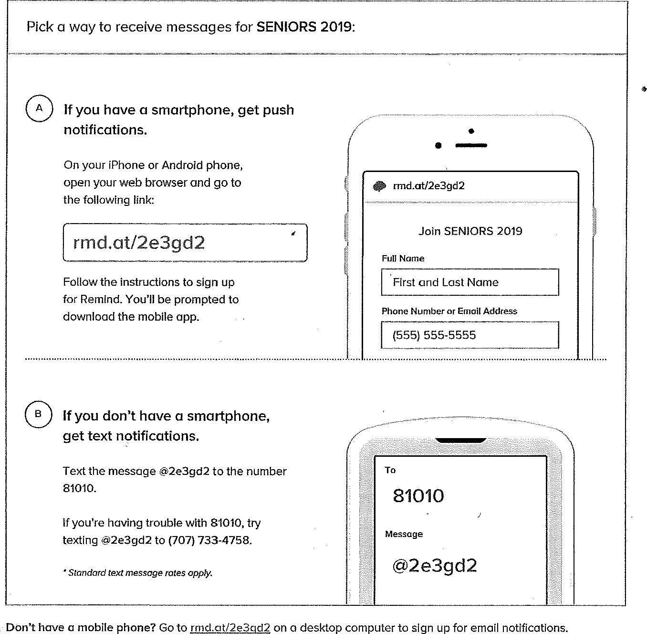
Sign up for important updates from C. Teel
Get information for SENIORS 2019 right on your phone – not on handouts.

Information on SAT or ACT Tests
- Use debit card to pay
- Register online www.collegeboard.org
SAT TEST @ G-PHS on March 9th & June 1st
SAT/ACT Practice www.March2success.com SAT DATES
Test Date | Normal Deadline | Late Registration* | Deadline for Changes | Online Score Release
Dec 1, 2018 | Nov 2, 2018 | Nov 13, 2018-mailed  Nov 20-online/phone | Nov 20, 2018 | Dec 14, 2018
Mar 9, 2019 | Feb 8, 2019 | Feb 19, 2019-mailed  Feb 27,2019-online/phone | Feb 27, 2019 | Mar 28, 2019
May 4, 2019 | Apr 5, 2019 | Apr 16, 2019-mailed  Apr 24, 2019-online/phone | Apr 24, 2019 | May 23, 2019
Jun 1, 2019 | May 3, 2019 | May 14, 2019-mailed  May 22, 2019-online/phone | May 22, 2019 | June 20, 2019

To Register go online to www.sat.org/register ACT DATES
Test Date | Registration Deadline | Late Fee Required | Score Release
Dec 8, 2018 | Nov 2, 2018 | Nov 3 – 19, 2018
Feb 9, 2019 | Jan 11, 2019 | Jan 12 – 18, 2019
Apr 13, 2019 | Mar 8, 2019 | Mar 9 – 25, 2019
Jun 8, 2019 | May 3, 2019 | May 4 – 20, 2019
Jul 13, 2019 | Jun 14, 2019 | Jun 15-24, 2019

TIPS FOR SUBMITTING SCHOLARSHIP APPLICATIONS

- SAT and/or ACT testing prior to the senior year provides time to retake the tests for improved scores and makes the test scores available when needed for scholarships and college entry.
- Mail applications well in advance of the deadline.
TIPS FOR SUBMITTING SCHOLARSHIP APPLICATIONS cont.

- Mail all required forms and documents in the same package to avoid lost forms, incomplete submissions and disqualification.
- Submit only documents requested. Additional information is not used to determine the applicant’s status.
- Submit all requested information in the form required (example: GPA in a 4-point un-weighted grade scale).
- Basic musts for students and counselors: [1] Write clearly; [2] Complete all required information; [3] complete only those sections designated for you; [4] Secure all required signatures; [5] Read instructions carefully; and [6] Submit only the information requested.
- When submitting tax information for financial aid, be sure the form shows the adjusted gross income, the number of dependents covered by that income, and any other required data. The first page of the standard Federal 1040 tax return provides the information. Submit only copies of tax forms unless originals are required.
- Apply for Scholarships for which you are qualified.
- Answer only the questions when given the opportunity for a written response. Additional information is not used to determine the applicant’s status.

Scholarships, FAFSA and, Letters of Recommendations
Seniors!!!
- Time to get started on your FAFSA. October 1st is when they begin accepting applications.
- Begin searching for scholarships. Many of scholarships require a letter of recommendation or an essay
- Make sure to ask teachers to proofread admissions and scholarship essays.
- Some schools have application deadline of December 1st. Stay on top of your deadlines.
- Keep track of everything you send to the schools.

Juniors!!
- Consider who you might ask for a letter of recommendation.
- Explore financial aid options and start talking to your parents about financial aid and other options available.

ON-LINE PRACTICE FOR ACT/SAT IS AVAILABLE ON THE WEB AT:
www.act.org and www.collegeboard.com
www.number2.com and www.studyhall.com
www.collegefortexans.com use the TOPCAT link

NCAA FORMS ARE AVAILABLE ON-LINE:
www.ncaaclearinghouse.net

FREE SCHOLARSHIPS SEARCHES:
www.fastweb.com
www.cashe.com
www.csfa.org
www.wiredscholar.com
www.scholarships.com
www.SchoolSoup.com
www.discovercolleges.com
http://tea.texas.gov/Presidential_Scholar/
http://www.comptroller.texas.gov
http://matchthepromise.org/)
http://www.finaid.org/scholarships
https://www.cappex.com
https://collegeboard.org
https://www.scholarships.com

MANY SCHOLARSHIPS AVAILABLE AT THIS SITE:
www.window.state.tx.us/scholars/aid/scholarship/scalhs.html
www.archwaystoopportunity.com
www.cbcfoundation.org

Need Money for College?
Go to: www.studentaid.ed.gov
www.scholarshipexperts.com
www.discussawards.com
Coastal Compass Education & Career Center, located in the La Palmera Mall
Emerging Leaders Initiative – for career options, alternative education option & more
www.coastalcompass.org

